### 

**COSMETICS SOFTWARE - Λ Λ Я Λ**

Project Report submitted in partial fulfillment of the requirements for

the award of the degree of

**BACHELOR OF COMPUTER APPLICATIONS (BCA)**

Department of Computer Science (UG)

# C:\Users\Student\Pictures\GCBC\newlogo.png

# *Submitted By*

**RASHIKA A**

**(21BCAC51)**

Under the guidance of

**Prof. Dr. Vishnu Priya**

**DEPARTMENT OF COMPUTER SCIENCE (UG)**

**BCA PROGRAMME**

**KRISTU JAYANTI COLLEGE (Autonomous)**

**K. Narayanapura, Kothanur P.O., Bangalore – 560077**



**DEPARTMENT OF COMPUTER SCIENCE (UG)**

**CERTIFICATE OF COMPLETION**

This is to certify that the project entitled **“COSMETICS Management System - AARA”** has been satisfactorily completed by **RASHIKA A, 21bcac51** in partial fulfillment of the award of the Bachelor of Computer Applications degree requirements prescribed by Kristu Jayanti College (Autonomous) Bengaluru (Affiliated to Bangalore University) during the academic year 2022 -23.

***Internal Guide Head of the Department***

***Valued by Examiners***

**1:_____________________ *Centre:* Kristu Jayanti College**

**2:____________________  *Date:***



**DECLARATION**

I, **Rashika A**, 21BCAC51 hereby declare that the project work entitled **“COSMETICS Management System - AARA”** is an original project work carried out by me, under the guidance of **Prof. Dr. Vishnu Priya.**

This project work has not been submitted earlier either to any University / Institution or any other body for the fulfillment of the requirement of a course of study.

Signature

Rashika A

Bengaluru

Date:

**ACKNOWLEDGEMENT**

The success of the project depends upon the efforts invested. It’s my duty to acknowledge and thank the individuals who has contributed to the successful completion of the project.

I take this opportunity to express my profound and wholehearted thanks **to Rev. Fr. Dr. AUGUSTINE GEORGE, PRINCIPAL, KRISTU JAYANTI COLLEGE, BANGALORE** for providing ample facilities made to undergo my project successfully.

I express my deep sense of gratitude and sincere thanks to our Head of the Department **Prof. SEVUGA PANDIAN** for his valuable advice.

I feel immense pleasure to thank my respected guide **Prof. Dr. Vishnu Priya** for sustaining Interest and providing dynamic guidance in aiding me to complete this project immaculately and impeccably and for being the source of my strength and confidence.

It is my duty to express my thanks to all Teaching and Non-Teaching Staff members of Computer science department who offered me help directly or indirectly by their suggestions. The successful completion of my project would not have been possible without my parent’s Sacrifice, guidance, and prayers. I take this opportunity to thank everyone for their continuous Encouragement. I convey my thankfulness to all my friends who were with me to share my happiness and agony.

Last but not the least I thank almighty God for giving me strength and good health throughout my project and enabling me to complete it successfully.

**TABLE OF CONTENTS**

|  |  |  |
| --- | --- | --- |
| **S.No** | **Topic** | **Page No** |
| 1.  1.1  1.2  2  2.1  2.2  2.3  3  3.1  3.2  3.3  3.4  4  4.1  4.2  5.  5.1  5.2  5.3  6  7  8  9  10  11 | Introduction  Problem Definition  Scope of the Project  System Study  Existing System  Feasibility Study  Proposed System  System Design  ER Diagram  DFD[lev0, lev1]  Gantt Chart  Input / Output Design  System Configuration  Hardware Requirements  Software Requirements  Details of Software  Overview of Frontend  Overview of Backend  About the Platform  Testing  Conclusion and Future Enhancement  Bibliography  APPENDICES A-Table Structure  APPENDICES B-Screenshots  APPENDICES C-Sample Report of test cases |  |

**CHAPTER 1**

**INTRODUCTION**

**Cosmetics Software** is a complete solution for managing a Shop, enable online purchasing, an enhanced tool that assists in organizing the day-to-day activities of a Shop. There is the need of an application for efficient management and handling customer orders. This Cosmetics Shop Management System keeps every record which is required for stock customer of that Shop and by reducing paperwork. This application is used for keeping the information of Admin, Customer, and Stock. These records are stored in the database with security. Your data be a secure and only authorized person can take the copy of data. This project is developed in visual studio using SQL server.

**1.1 PROBLEM DEFINITION**

Having a cosmetic business is too tricky, which requires a better management system. This system should improve sales and make the business/store run smoothly. Inventory management software is the only solution for this. It will help you understand all these needs and find out the measures.

An inventory system helps you maintain optimum inventory levels and reduce costs in the cosmetic business because the cosmetics industry has so many products.

These products have different types of brands and products that must be sold before they expire. And if the expiry date is passed, they also need to be replenished at the right place.

The system can generate various reports useful for the management and as it is quite user friendly it saves time and reduce the chances of error occurrences. The co-ordination of various functions can be achieved and miss management does not take place.

* **TECHNOLOGY OR TOOLS USED –**
* VB.NET
* MySQL
* Windows 11
* **MODULES**
* **LOGIN-** consists of admin or customer user-id and password. Also has Sign-in option. Consisting of a total three login options- Admin, Sign In (existing user), Sign Up (Register page or first time user).
* **HOME PAGE**- database of product availability,image, review, and rating along with price. A categorised view of products according to product name and in accordance with brands.
* **CUSTOMER DETAILS-** delivery address to check regional availability, phone number and gender for suitable suggestions. These details will be viewed by admins alone hence data security is ensured.
* **PRODUCT LIST-** categorised view for easy browsing. This module is also accessed by admins alone for product management, facilitating optimum product circulation.
* **CART-** to add desired items for easier checkout.
* **BILLING-** payment options (COD, UPI & cash) and checkout. The cash on delivery directs the customer to the invoice page. The UPI option leads to a section to enter UPI id and then payment is processed. In the card option, it takes the customer to a page to enter card details.

**1.2 SCOPE OF THE PROJECT**

Cosmetic software is an standalone application created using VB.Net. The project provides user with a flexible & attractive GUI & shows them a list of products & carry out all the shopping activities online. This project is developed for users to have a brief look at the cosmetics products without visiting the store. The website displays different kinds of products of different brands so that user can easily get their expected cosmetic products.

**CHAPTER 2**

**2SYSTEM STUDY**

**2.1 EXISTING SYSTEM**

This project was developed with the aim of providing customer the liberty to view and purchase cosmetic products without having to physically visit any store. The application displays different kinds of products of various brands- (in other words A to Z manual for cosmetic shopping) so that the customer can get the required products. It provides good user interface which enable ease to use. It provides security to the database as well. This system allows one to view the details of any record, locate any cosmetic product wanted by the user. It has reduced clerical work. Hence produces great speed and reduced time consumption for customer.

**DEMERITS OF MANUAL SYSTEM**

➤ Takes longer time for in-person cosmetics purchase.

➤ It is expensive too.

➤ Need an agent.

➤ You have to go through the traffic and the parking, experiencing a lot of difficulties.

➤ Processes are more prone to be tedious.

➤ Loss of time and cost due to stock of clothes.

➤ Categorized according to brands for easier shopping.

There are chances for misplacing of important clothes. This will lead to loss of to misplace the bulk order of clothes.

**2.2 FEASIBILITY SYSTEM**

A feasibility study is undertaken to determine to the possibility or probability of either improving the existing system or developing a completely new system. It helps to obtain the overview of the problem and to get a rough assessment of whether other feasible solution exists.

The Feasibility study is divided in to three parts:

* **ECONOMIC FEASIBILITY**
* **TECHNICAL FEASIBILITY**
* **OPERATIONAL FEASIBILITY**

**ECONOMIC FEASIBILITY**

Economic analysis is most frequently used for evaluation of the effectiveness of the system More commonly known as cost benefit analysis the procedure is to determine the benefit and saving that are expected from a system and compare them with costs, decisions is made to design and implement the system.

This part of feasibility study gives the top management the economic justification for the new system. This is an important input to the management the management, because very often the top management does not like to get confounded by the various technicalities that bound to the associated with a project of this kind. A simple economic analysis that gives the actual compensates of costs and benefits is much more meaningful in such cases. This part of feasibility study gives the top management the economic justification for the new system. This is an important input to the management the management, because very often the top management does not like to get confounded by the various technicalities that bound to be associated with a project of this kind. A simple economic analysis that gives the actual comparison of costs and benefits is much more meaningful in such cases.

In the system, the organization is most satisfied by economic feasibility. Because, if the organization implements this system, it need not require any additional hardware resources as well as it will be saving lot of time.

**TECHNICAL FEASIBILITY**

Technical feasibility centers on the existing manual system of the test management process and to what extent it can support the system According to feasibility analysis procedure the technical feasibility of the system is analyzed and the technical requirements such as software facilities, procedure, inputs are identified. It is also one of the important phases of the system development activities. The system offers greater levels of user friendliness combined with greater processing speed. Therefore, the cost of maintenance can be reduced. Since, processing speed is very high and the work is reduced in the maintenance point of view management convince that the project is operationally feasible.

**BEHAVIOURAL FEASIBILITY**

People are inherently resistant to change and computer has been known to facilitate changes. An estimate should be made of how strong the user is likely to move towards the development of computerized system. These are various levels of users in order to ensure proper authentication and authorization and security of sensitive data of the organization.

**2.3 PROPOSED SYSTEM**

The objective is to overcome the major limitation of the existing system enabling effective management of the customer's details thereby improving the performance. With improved computerization using involved in the maintenance of customer details. Easy retrieval of data will be made possible by finding techniques validation of data needs to be prioritized. Proper monitoring of other processes from customer registration to activation will be and be potentially achieved to ease out the activity and performance. It is platform dependent, the database constricts the transfer of application we are aiming to ensure prioritization of seller and their respective brands with rising competition in the market we aim to improvise and propose products that will lead to the market.

This project has login modules for authorized login ensuring stronger security system. Categorized view enable better traversal for organized shopping to the users. Cart provides for review before proceeding to payment options. Payments are up-to-date using a total of three payment methods namely- cash (cash on delivery, COD), UPI and card with protected transaction.

**ADVANTAGES**

To overcome the above-mentioned inadequacies of the system; One of the best solution is to computerize whole system by developing software for it. Using our software all the transactions are recorded in the concerned database tables. The proposed system is supposed to automate much of the manual procedures and functions.

➤ Proposed system provides security.

➤ Low cost

➤You need carry the purchased products.

➤ It saves the time, effort and avoid dealing cashiers.

➤ The proposed system is designed in such a way that many of the input operations are done through well-structured forms.

➤ The forms are capable of validating and checking the integrity and correctness of the

input.

➤ Proper validations helped to retrieve the information with ease which helps the firm to have a good relation with Customers as well as with the working with our website.

The proposed system can be used even by the native users and it does not require any educational level, experience level, experience and technical expertise in computer field but it will be of good use if the user has the good knowledge of how to operate a computer.

**CHAPTER 3**

# SYSTEM DESIGN

In the design phase the architecture is established. This phase starts with the requirement document delivered by the requirement phase and maps the requirements into an architecture. The architecture defines the components, their interfaces and behaviours. The deliverable design document is the architecture. The design document describes a plan to implement the requirements. This phase represents the ``how'' phase.

Details on computer programming languages and environments, machines, packages, application architecture, distributed architecture layering, memory size, platform, algorithms, data structures, global type definitions, interfaces, and many other engineering details are established.

The design may include the usage of existing components. Analysing the trade-offs of necessary complexity allows for many things to remain simple which, in turn, will eventually lead to a higher quality product. The architecture team also converts the typical scenarios into a test plan. In our approach, the team, given a complete requirement document, must also indicate critical priorities for the implementation team.

A critical implementation priority leads to a task that has to be done right. If it fails, the product fails. If it succeeds, the product might succeed. At the very least, the confidence level of the team producing a successful product will increase. This will keep the implementation team focused. Exactly how this information is conveyed is a skill based on experience more than a science based on fundamental foundations. System design is the process of defining the architecture components, modules, interfaces, and data for a system to satisfy specified requirements.

Systems design could be seen as the application of systems theory to product development. There is some overlap with the disciplines of systems analysis systems architecture and systems engineering. If the broader topic of product development blends the perspective of marketing, design, and manufacturing into a single approach to product development," then design is the act of taking the marketing information and creating the design of the product to be manufactured. Systems design is therefore the process of defining and developing systems to satisfy specified requirements of the user.

Until the 1990s, systems design had a crucial and respected role in the data processing industry. In the 1990s, standardization of hardware and software resulted in the ability to build modular systems. The increasing importance of software running on generic platforms has enhanced the discipline of software enginee[ring.](https://en.wikipedia.org/wiki/Software_engineering)

Object-oriented analysis and design methods are becoming the most widely used methods for computer systems design. The UML has become the standard language in object-oriented analysis and design. It is widely used for modelling software systems and is increasingly used for high designing non software systems and organizations.

### ARCHITECTURAL DESIGN:

The architectural design of a system emphasizes the design of the system architecture that describes the structure, behavior and more views that system and analysis.

### LOGICAL DESIGN:

The logical design of a system pertains to an abstract representation of the data flows, inputs and outputs of the system. This is often conducted via modelling, using an over-abstract (and sometimes graphical) model of the actual system. In the context of systems, designs are included. Logical design includes entity-relationship diagrams (ER diagrams).

### PHYSICAL DESIGN:

The physical design relates to the actual input and output processes of the system. This is explained in terms of how data is input into a system, how it is verified/authenticated, how it is processed, and how it is displayed. In physical design, the following requirements about the system are decided.

Input requirement, Output requirements, Storage requirements, Processing requirements,

System control and backup or recovery.

Put another way, the physical portion of system design can generally be broken down into three sub- tasks:

User Interface Design. Data Design.

Process Design

User Interface Design is concerned with how users add information to the system and with how the system presents information back to them. Data Design is concerned with how the data is represented and stored within the system.

Finally, Process Design is concerned with how data moves through the system, and with how and where it is validated, secured and/or transformed as it flows into, through and out of the system.

At the end of the system design phase, documentation describing the three sub-tasks is produced and made available for use in the next phase. Physical design, in this context, does not refer to the tangible physical design of an information system.

To use an analogy, a personal computer's physical design involves input via a keyboard, processing within the CPU, and output via a monitor, printer, etc.

It would not concern the actual layout of the tangible hardware, which for a PC would be a monitor, CPU, motherboard, hard drive, modems, video/graphics cards, USB slots, etc.

It involves a detailed design of a user and a product database structure processor and a control processor. The H/S personal specification is developed for the proposed system.

In naming entities, remember to use singular nouns. However, adjectives may be used to distinguish entities belonging to the same class (part-time employee and full -time employee, for example).

Meanwhile attribute names must be meaningful, unique, system independent, and easily understandable.

Remove vague, redundant or unnecessary relationships between entities. Never connect a relationship to another relationship.

Make effective use of colors.

You can use colors to classify similar entities or to highlight key areas in your diagrams. You can draw entity relationship diagrams manually, especially when you are just informally showing simple systems to your peers.

However, for more complex systems and for external audiences, you need diagramming software such as Creasey’s to craft visually engaging and precise ER diagrams.

The ER Diagram Software offered by Cordately as an online service is pretty easy to use and is a lot more affordable than purchasing licensed software.

It is also perfectly suited for development teams because of its strong support for collaboration.

## THE HISTORY OF ENTITY RELATIONSHIP DIAGRAMS:

Peter Chen developed ERDs in 1976. Since then, Charles Bachman and James Martin have added some slight refinements to the basic ERD principles.

## STRUCTURE OF ENTITY RELATIONSHIP DIAGRAM WITH COMMON ERD:

**Notations:** An entity relationship diagram is a means of visualizing how the information a system produces is related. There are five main components of an ERD:

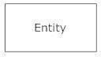**Entities**, which are represented by rectangles. An entity is an object or concept about which you want to store information.

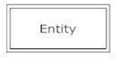A weak entity is an entity that must defined by a foreign key relationship with another entity as it cannot be uniquely identified by its own attributes alone.

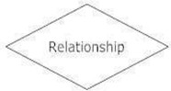**Actions**, which are represented by diamond shapes, show how two entities share information in the database.

In some cases, entities can be self-linked. For example, employees can supervise other employees.

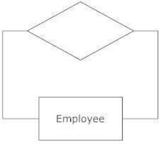

**Attributes**, which are represented by ovals. A key attribute is the unique, distinguishing characteristic of the entity. For example, an employee's social security number might be the employee's key attribute.

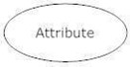

A multivalued attribute can have more than one value. For example, an employee entity can have multiple skill values.

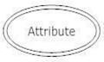

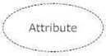A derived attribute is based on another attribute. For example, an employee's monthly salary is based on the employee's annual salary.

**Connecting lines**, solid lines that connect attributes to show the relationships of entities in the ER Diagram.

**Cardinality** specifies how many instances of an entity relate to one instance of another entity. Ordinality is also closely linked to cardinality. While cardinality specifies the occurrences of a relationship, ordinality describes the relationship as either mandatory or optional. In other words, cardinality specifies the maximum number of relationships and ordinality specifies the absolute minimum number of relationships.

There are many notation styles that express cardinality .

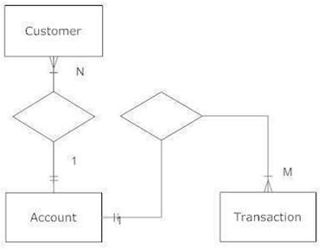

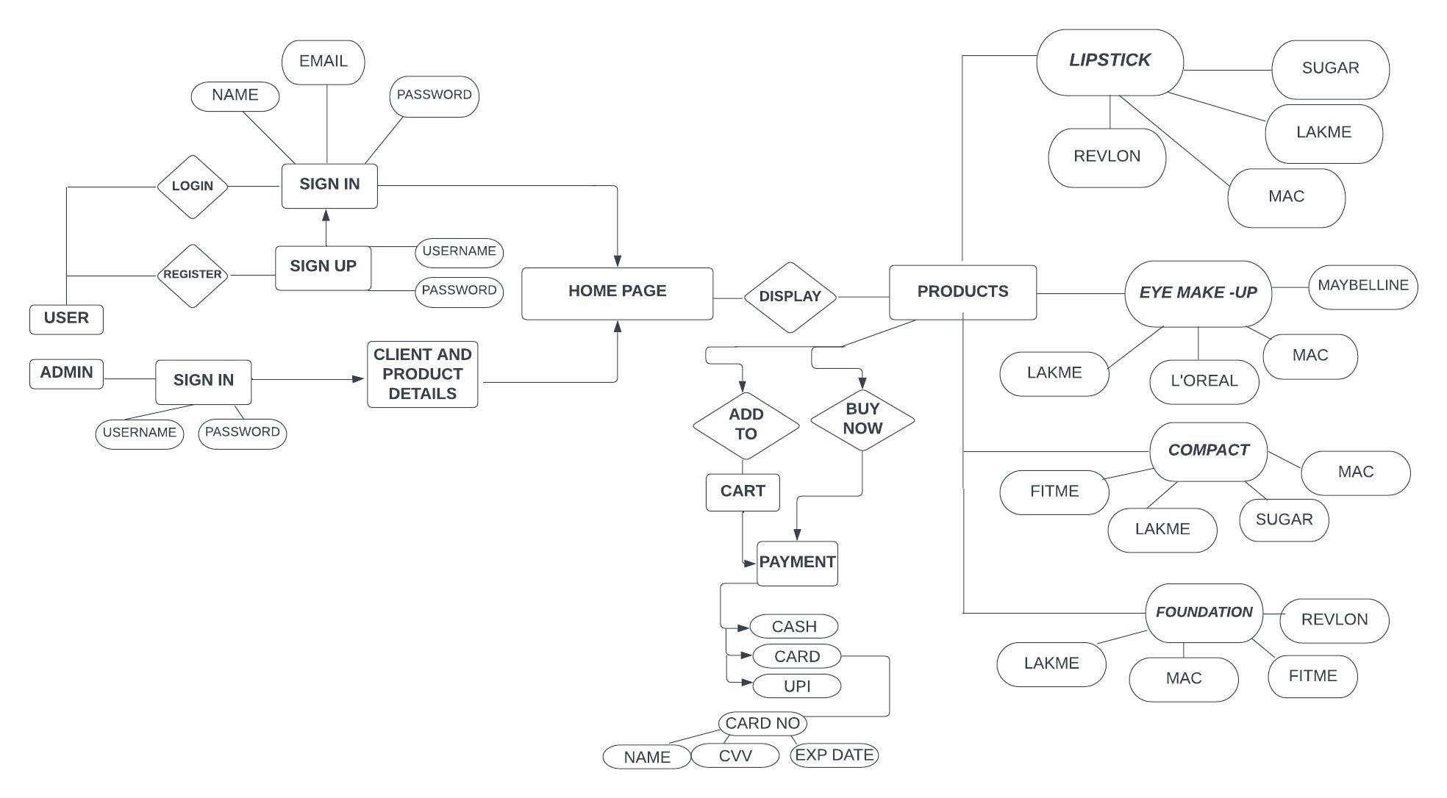

## DATA FLOW DIAGRAM (LEVEL 0 AND LEVEL 1):

The Data Flow Diagrams (DFDs) are used for structure analysis and design. DFDs show the flow of data from external entities into the system. DFDs also show how the data moves and is transformed from one process to another, as well as its logical storage. The following symbols are used within DFDs. For clarity, a key has been provided at the bottom of this page.

A data flow diagram (DFD) is a graphical representation of the "flow" of data through an information system, modelling its process aspects. A DFD is often used as a preliminary step to create an overview of the system, which can later be elaborated. DFDs can also be used for the visualization of data processing (structured design).

A DFD shows what kind of information will be input to and output from the system, where the data will come from and go to, and where the data will be stored. It does not show information about the timing of process or information about whether processes will operate in sequence or in parallel (which is shown on a flowchart).

### HISTORY:

[Larry Constantine,](https://en.wikipedia.org/wiki/Larry_Constantine) the original developer of structured design, based on Martin and Estrin's "Data Flow Graph" model of computation.

Starting in the 1970s, data flow diagrams (DFD) became a popular way to visualize the major steps and data involved in software system processes. DFDs were usually used to show data flow in a computer system, although they could in theory be applied to [business process modelling. D](https://en.wikipedia.org/wiki/Business_process_modeling)FD were useful to document the major data flows or to explore a new high-level design in terms of data flow.

## THEORY:

**DATA FLOW DIAGRAM EXAMPLE:**

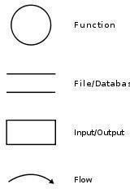

The Data Flow Diagrams (DFDs) are used for structure analysis and design. DFDs show the flow of data from external entities into the system. DFDs also show how the data moves and is transformed from one process to another, as well as its logical storage. The following symbols are used within DFDs. For clarity, a key has been provided at the bottom of this page.

A data flow diagram (DFD) is a graphical representation of the "flow" of data through an information system, modelling its process aspects. A DFD is often used as a preliminary step to create an overview of the system, which can later be elaborated. DFDs can also be used for the visualization of data processing (structured design).

A DFD shows what kind of information will be input to and output from the system, where the data will come from and go to, and where the data will be stored. It does not show information about the timing of process or information about whether processes will operate in sequence or in parallel (which is shown on a flowchart).

Data flow diagrams are one of the three essential perspectives of the structured-systems analysis and design method. The sponsor of a project and the end users will need to be briefed and consulted throughout all stages of a system's evolution. With a data flow diagram, users are able to visualize how the system will operate, what the system will accomplish, and how the system will be implemented.

The old system's dataflow diagrams can be drawn up and compared with the new system's data flow diagrams to draw comparisons to implement a more efficient system. Data flow diagrams can beused to provide the end user with a physical idea of where the data they input ultimately has an effect upon the structure of the whole system from order to dispatch to report. How any system is developed can be determined through a data flow diagram model.

In the course of developing a set of levelled data flow diagrams the analyst/designer is forced to address how the system may be decomposed into component sub-systems, and to ide[ntify the transaction data](https://en.wikipedia.org/wiki/Transaction_data) [in t](https://en.wikipedia.org/wiki/Transaction_data)he [data model.](https://en.wikipedia.org/wiki/Data_model)

Data flow diagrams can be used in both Analysis and Design phase of the [SDLC.](https://en.wikipedia.org/wiki/Systems_development_life_cycle)

There are different notations to draw data flow diagrams (Yourdon & Coad and [Gane](https://en.wikipedia.org/wiki/Chris_Gane_%28computer_scientist%29) [&](https://en.wikipedia.org/wiki/Chris_Gane_%28computer_scientist%29) [Sarson),](https://en.wikipedia.org/wiki/Trish_Sarson) defining different visual representations for processes, data stores, data flow, and external entities.

## PHYSICAL VS LOGICAL DFD :

A logical DFD captures the data flows that are necessary for a system to operate. It describes the processes that are undertaken, the data required and produced by each process, and the stores needed to hold the data. On the other hand, a physical DFD shows how the system is actually implemented, either at the moment (Current Physical DFD), or how the designer intends it to be in the future (Required Physical DFD).

Thus, a Physical DFD may be used to describe the set of data items that appear on each piece of paper that move around an office, and the fact that a particular set of pieces of paper are stored together in a filing cabinet. It is quite possible that a Physical DFD will include references to data that are duplicated, or redundant, and that the data stores, if implemented as a set of [database tables, w](https://en.wikipedia.org/wiki/Database_table)ould constitute an un-normalised (or denormalised) relational database. In contrast, a Logical DFD attempts to capture the data flow aspects of a system in a form that has neither redundancy nor duplication.

## DATA FLOW SYMBOLS AND THERE MEANINGS:-

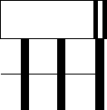

An entity. A source of data or a destination for data.

**Source/Sink:** Represented by rectangles in the diagram. Sources and Sinks are external entities which are sources or destinations of data, respectively.



**Process:** Represented by circles in the diagram. Processes are responsible for manipulating the data. They take data as input and output an altered version of the data.



**Data Store:** Represented by a segmented rectangle with an open end on the right. Data Stores are both electronic and physical locations of data. Examples include databases, directories, files, and even filing cabinets and stacks of paper.



In our course, we need to understand and be able to draw 2 types of Data Flow Diagrams, they are Level-0 and Level 1 DFD’s. In this blog, I will hopefully make it easier to understand the differences between the two types of DFD’s and help understand how to draw a DFD for the exam.

Firstly we will look at level-0 DFD’s and give an example. Then we will look at Level 1 DFD’s and

give an example.

A level-0 DFD is the most basic form of DFD. It aims to show how the entire system works at a glance. There is only one process in the system and all the data flows either into or out of this process.Level- 0 DFD’s demonstrates the interactions between the process and external entities. They do not contain Data Stores.

When drawing Level-0 DFD’s, we must first identify the process, all the external entities and all the data flows. We must also state any assumptions we make about the system. It is advised that we draw the process in the middle of the page. We then draw our external entities in the corners and finally connect our entities to our process with the data flows.

## LEVEL ZERO DIAGRAM

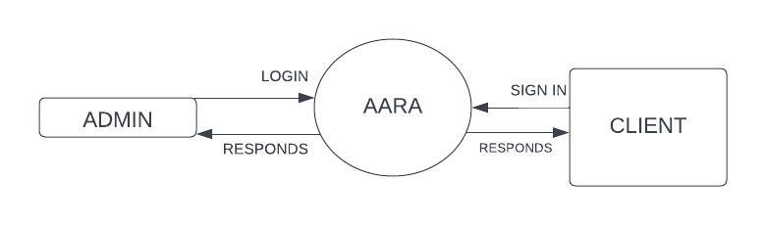

**LEVEL 1 DFD’s:**

Level 1 DFD’s aim to give an overview of the full system. They look at the system in more detail. Major processes are broken down into subprocesses. Level 1 DFD’s also identifies data stores that are used by the major processes. When constructing a Level 1 DFD, we must start by examining the Context Level DFD.

We must break up the single process into its subprocesses.

We must then pick out the data stores from the text we are given and include them in our DFD.

Like the Context Level DFD’s, all entities, data stores and processes must be labelled.

We must also state any assumptions made from the text.

Below is the Level 1 DFD of BLOOD BANK MANAGEMENT SYSTEM.

Below is the Level 1 DFD :-

## LEVEL ONE DIAGRAM :-

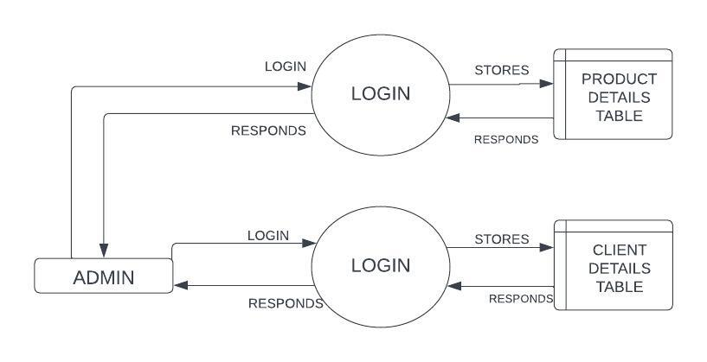

# 1.2 GANTT CHART:

A Gantt chart is a type of bar chart, devised by Henry Gantt in the 1910s, that illustrates a project schedule. Gantt charts illustrate the start and finish dates of the terminal elements and summary elements of a project. Terminal elements and summary elements comprise the work breakdown structure of the project.

Modern Gantt charts also show the dependency (i.e., precedence network) relationships between activities. Gantt charts can be used to show current schedule status using percent-complete shadings and a vertical "TODAY" line as shown here.

Although now regarded as a common charting technique, Gantt charts were considered revolutionary when first introduced. This chart is also used in information technology to represent data that has been collected.

## HISTORICAL DEVELOPMENT:

The first known tool of this type was developed in 1896 by Karol Adamiecki, who called it a harmonogram , Adamiecki did not publish his chart until 1931, however, and only in Polish, which limited both its adoption and recognition of his authorship.

The chart is named after Henry Gantt (1861– 1919), who designed his chart around the years 1910– 1915.

One of the first major applications of Gantt charts was by the United States during World War I, at the instigation of General William Crozier

In the 1980s, personal computers allowed widespread creation of complex and elaborate Gantt charts. The first desktop applications were intended mainly for project managers and project schedulers.

With the advent of the Internet and increased collaboration over networks at the end of the 1990s, Gantt charts became a common feature of web-based applications, including collaborative groupware.

## GANTT CHART BENEFITS:

**CLARITY:** One of the biggest benefits of a [Gantt chart is](http://www.brighthubpm.com/templates-forms/3418-using-excel-to-create-a-gantt-chart/) the tool's ability to boil down multiple tasks and timelines into a single document. Stakeholders throughout an organization can easily understand where teams are in a process while grasping the ways in which independent elements come together toward project completion.

**COMMUNICATION:** Teams can use Gantt charts to replace meetings and enhance other status updates. Simply clarifying chart positions offers an easy, visual method to help team members understand task progress.

**MOTIVATION:** Some teams or team members become more effective when faced with a form of external motivation. Gantt charts offer teams the ability to focus work at the front of a task timeline, or at the tail end of a chart segment. Both types of team members can find Gantt charts meaningful as they plug their own work habits into the overall project schedule.

**CO ORDINATION:** For project managers and resource schedulers, the benefits of a Gantt chart include the ability to sequence events and reduce the potential for overburdening team members. Some project managers even use combinations of charts to break down projects into more manageable sets of tasks.

**CREATIVITY:** Sometimes, a lack of time or resources forces project managers and teams to find creative solutions. Seeing how individual tasks intertwine on Gantt charts often encourages new partnerships and collaborations that might not have evolved under traditional task assignment systems.

**TIME MANAGEMENT**: Most managers regard scheduling as one of the major benefits of Gantt charts in a creative environment. Helping teams understand the overall impact of project delays can foster stronger collaboration while encouraging better task organization.

**FLEXIBILITY:** Whether you [use Excel to generate Gantt charts or](http://www.brighthubpm.com/templates-forms/31029-a-microsoft-excel-project-planning-form/) you load tasks into a more precise chart generator, the ability to issue new charts as your project evolves lets you react to unexpected changes in [project scope or](http://www.brighthubpm.com/project-planning/10057-defining-the-project-scope-tips-amp-free-template/) timeline. While revising your project schedule too frequently can eliminate some of the other benefits of Gantt charts, offering a realistic view of a project can help team members recover from setbacks or adjust to other changes.

**MANAGEABILITY:** For project managers handling complex assignments, like software publishing or event planning, the benefits of Gantt charts include externalizing assignments. By visualizing all

of the pieces of a project puzzle, managers can make more focused, effective decisions about resources and timetables.

**EFFICIENCY:** Another one of the benefits of Gantt charts is the ability for teams members to leverage each other’s deadlines for maximum efficiency. For instance, while one team member waits on the outcome of three other tasks before starting a crucial piece of the assignment, he or she can perform other project tasks. Visualizing resource usage during projects allows managers to make better use of people, places, and things.

**ACCOUNTABILITY:** When project teams face major organizational change, documenting effort and outcomes becomes crucial to career success. Using Gantt charts during critical projects allows both project managers and participants to track team progress, highlighting both big wins and major failures. During professional review periods, team members who frequently exceed expectations can leverage this documentation into larger raises or bonuses.

## GANTT CHART IMPORTANCE:

The project's summary and terminal elements, which combine to form the project's internal structure, are shown on the Gantt chart. Many charts will also depict the precedence rankings and dependencies of various tasks within the project. The charts can illustrate the start and finish project terminal elements in project management.

It can also show summary elements and terminal dependencies. The smallest task tracked as part of the project effort is known as a terminal element. Gantt chart represents the tasks in most modern project scheduling packages. However other management applications use simpler communication tools such as message boards, to-do lists and simple scheduling etc., therefore, they do not use Gantt charts as heavily.

The way to create this chart begins by determining and listing the necessary activities. Next, sketch out how you expect the chart to look. List which items depend on others and what activities take place when. For each activity, list how many man-hours it will require, and who is responsible.

Lastly, determine the throughput time. This technique's primary advantage is its good graphical overview that is easy to understand for nearly all project participants and stakeholders. Its primary disadvantage is its limited applicability for many projects, since projects are often more complex than can be effectively communicated with this chart.

**GANNT CHART**

# SOFTWARE CONFIGURATION:

## HARDWARE REQUIREMENTS

PROCESSOR : INTEL CORE SPEED : 1.50GHZ

RAM : 4GB

## SOFTWARE REQUIREMENTS:-

FRONTEND : VB.NET (VISUALSTUDIO)2019

BACKEND : SQL SERVER DOCUMENTATON : MS WORD 2007 GANTT CHART : MS PROJECT 2013 OPERATING SYSTEM : WINDOWS10

# DETAILS OF SOFTWARE:

1. **OVERVIEW OF FRONT-END:**

Microsoft Visual Studio 2019 is an integrated development environment (IDE) from Microsoft. It is used to develop computer programs for Microsoft Windows, as well as web sites, web apps, web services and mobile apps. Visual Studio uses Microsoft software development platforms such as Windows API, Windows Forms, Windows Presentation Foundation, Windows Store and Microsoft Silverlight. It can produce both native code and managed code.

Visual Studio supports different programming languages and allows the code editor and debugger to support nearly any programming language, provided a language-specific service exists. Built-in languages include C, C++, Visual C++ and VB.NET. Support for other languages such as Python, Ruby, Node.js, and M among others is available via language services installed separately.

It also supports XML/XSLT, HTML/XHTML, JavaScript and CSS. Java (and J#) were supported in the past**.** Microsoft provides a free version of Visual Studio called the Community edition that supports plugins and is available at no cost for all users. Support for programming languages isadded by using a specific VSPackage called a Language Service.

A language service defines various interfaces which the VSPackage implementation can implement to add support for various functionalities. Functionalities that can be added this way include syntax coloring, statement completion, brace matching, parameter information tooltips, member lists and error markers for background compilation.

If the interface is implemented, the functionality will be available for the language. Language services are implemented on a per-language basis. The implementations can reuse code from the parser or the compiler for the language. Language services can be implemented either in native code or managed code. For native code, either the native COM interfaces or the Babel Framework can be used. For managed code, the MPF includes wrappers for writing managed language services.

## FEATURES:

Boolean Conditions Automatic Garbage Collection Standard Library

Assembly Versioning Properties and Events

Delegates and Events Management Easy-to-use Generics

Indexers

Conditional Compilation Simple Multithreading

## ADVANTAGES:

The structure of the [Basic programming language is](http://en.wikipedia.org/wiki/BASIC) very simple, particularly as to the executable code.

VB is not only a language but primarily an integrated, interactive development environment

(“[IDE“).](http://en.wikipedia.org/wiki/Integrated_development_environment)

The VB-IDE has been highly optimized to support rapid application development(“RAD”). It is particularly easy to develop [graphical user interfaces](http://en.wikipedia.org/wiki/Graphical_user_interface) [an](http://en.wikipedia.org/wiki/Graphical_user_interface)d to connect them to handler functions provided by the application.

The graphical user interface of the VB-IDE provides intuitively appealing views for the management of the program structure in the large and the various types of entities (classes, modules, procedures, forms.

VB provides a comprehensive interactive and context-sensitive online help system.

When editing program texts the “[IntelliSense” t](http://en.wikipedia.org/wiki/IntelliSense)echnology informs you in a little popup window about the types of constructs that may be entered at the current cursor location.

VB is a component integration language which is attuned to Microsoft’s Component Object Model (“COM”).

COM components can be written in different languages and then integrated using VB.

Interfaces of COM components can be easily called remotely via Distributed COM (“DCOM”), which makes it easy to construct distributed applications.

COM components can be embedded in / linked to your application’s user interface and also in/to

stored documents ([Object Linking and Embedding](http://en.wikipedia.org/wiki/Object_Linking_and_Embedding) “OLE”, “Compound Documents”). There is a wealth of readily available COM components for many different purposes. Visual Basic is built around the .NET environment used by all Microsoft.

.

# OVERVIEW OF BACK-END

Microsoft SQL Server is a relational database management system developed by Microsoft. As a database server, it is a software product with the primary function of storing and retrieving data as requested by other software applications—which may run either on the same computer or on another computer across a network (including the Internet).

Microsoft markets at least a dozen different editions of Microsoft SQL Server, aimed at different audiences and for workloads ranging from small single-machine applications to large Internet-facing applications with many concurrent users. The protocol layer implements the external interface to SQL Server. All operations that can be invoked on SQL Server are communicated to it via a Microsoft- defined format, called Tabular Data Stream (TDS).

TDS is an application layer protocol, used to transfer data between a database server and a client. Initially designed and developed by Sybase Inc. for their Sybase SQL Server relational database engine in 1984, and later by Microsoft in Microsoft SQL Server, TDS packets can be encased in other physical transport dependent protocols, including TCP/IP, named pipes, and shared memory. Consequent access to SQL Server is available over these protocols. In addition, the SQL Server API is also exposed over web services.

A Relational Data Base Management System (RDBMS) is software that: Enables you to implement a database with tables, columns and indexes. Guarantees the Referential Integrity between rows of various tables. Updates the indexes automatically. Interprets an SQL query and combines information from various tables. MySQL is a leading open source database management system.

It is a multiuser, multithreaded database management system. MySQL is especially popular on the web. It is one of the parts of the very popular LAMP platform. Linux, Apache, MySQL and PHP. MySQL database is available on most important OS platforms. It runs on BSD Unix, Linux, Windows or Mac. Wikipedia, YouTube, Facebook use MySQL. These sites manage millions of queries each day. MySQL comes in two versions.

MySQL server system and MySQL embedded system. The MySQL server software and the client libraries are dual-licensed.

## ADVANTAGES:-

MySQL is becoming so popular because of many good reasons:

MySQL is released under an open-source license. So you have nothing to pay to use it. MySQL is a very powerful program in its own right. It handles a large subset of the functionality of the most expensive and powerful database packages. MySQL uses a standard form of the well-known SQL data language. MySQL works on many operating systems and with many languages including PHP, PERL, C, C++, JAVA, etc. MySQL works very quickly and works well even with large data sets. MySQL is very friendly to PHP, the most appreciated language for web development. MySQL supports large databases, up to 50 million rows or more in a table. The default file size limit for a table is 4GB, but you can increase this (if your operating system can handle it) to a theoretical limit of 8 million terabytes (TB). MySQL is customizable. The open-source GPL license allows programmers to modify the MySQL software to fit ther own specific environments.

## FEATURES:

Written in C and C++.

Tested with a broad range of different compilers.

Works on many different platforms. .

For portability, uses **CMake** in MySQL 5.5 and up. Previous series use GNU Automake, Autoconf, and Libtool.

Tested with Purify (a commercial memory leakage detector) as well as with Valgrind, a GPL tool.

Uses multi-layered server design with independent modules.

Designed to be fully multi-threaded using kernel threads, to easily use multiple CPUs if they are available.

Provides transactional and nontransactional storage engine

Fixed-length and variable-length string types.

**Statements and Functions** mysql> SELECT CONCAT(first_name, ' ', last_name) -> FROM citizen

-> WHERE income/dependents > 10000 AND age > 30;Full support for SQL GROUP BY and ORDER BY

clauses. Support for and[GROUP_CONCAT()).](https://dev.mysql.com/doc/refman/5.7/en/group-by-functions.html)

Support for LEFT OUTER JOIN and RIGHT OUTER JOIN with both standard SQL and ODBC syntax. Support for aliases on tables and columns as required by standard SQL. Some were changed (affected) to, return the number of rows matched instead by setting a flag when connecting to the server. Support for MySQL-specific [SHOW st](https://dev.mysql.com/doc/refman/5.7/en/show.html)atements that retrieve information about databases, storage engines, tables, and indexes. Support for the INFORMATION_SCHEMA database, implemented according to standard SQL.

An [EXPLAIN st](https://dev.mysql.com/doc/refman/5.7/en/explain.html)atement to show how the optimizer resolves a query.

Independence of function names from table or column names. For example, ABS is a valid column name. The only restriction is that for a function call, no spaces are permitted between the function name and the “(” that follows it.You can refer to tables from different databases in the same statement.

### SECURITY:

A privilege and password system that is very flexible and secure, and that enables host-based verification.

Password security by encryption of all password traffic when you connect to a server.

### SCALABILITY AND LIMITS:

Support for large databases. We use MySQL Server with databases that contain 50 million records. We also know of users who use MySQL Server with 200,000 tables and about 5,000,000,000 rows.

Support for up to 64 indexes per table. Each index may consist of 1 to 16 columns or parts of columns. The maximum index width for [InnoDB ta](https://dev.mysql.com/doc/refman/5.7/en/innodb-storage-engine.html)bles is either 767 bytes or 3072 bytes. The maximum index width for [My ISAM ta](https://dev.mysql.com/doc/refman/5.7/en/myisam-storage-engine.html)bles is 1000 bytes. An index may use a prefix of a column for [CHAR,](https://dev.mysql.com/doc/refman/5.7/en/char.html) [VARCHA](https://dev.mysql.com/doc/refman/5.7/en/char.html)[R,](https://dev.mysql.com/doc/refman/5.7/en/blob.html) [BLOB, or TEXT co](https://dev.mysql.com/doc/refman/5.7/en/blob.html)lumn types.

### CONNECTIVITY:

Clients can connect to MySQL Server using several protocols:

Clients can connect using TCP/IP sockets on any platform.

On Unix systems, clients can connect using Unix domain socket files.

### LOCALIZATION:

The server can provide error messages to clients in many languages.

Full support for several different character sets, including latin1 (cp1252), german, big5, ujis, several Unicode character sets, and more. For example, the

Scandinavian characters “å”, “ä” and “ö” are permitted in table and column names. All data is saved in the chosen character set.

Sorting and comparisons are done according to the chosen character set and collation

(using latin1 and Swedish collation by default). It is possible to change this when the MySQL server is started. To see an example of very advanced sorting, look at the Czech sorting code. MySQL Server supports many different character sets that can be specified at compile time and runtime.

The server time zone can be changed dynamically, and individual clients can specify their own time zone.

### CLIENTS AND TOOLS:

MySQL includes several client and utility programs. These include both command-line programs and graphical programs.

MySQL Server has built-in support for SQL statements to check, optimize, and repair tables.

These statements are available from the command line through the mysqlcheck client. MySQL also includes myisamch, a very fast command-line utility for performing these operations on MyISAM tables..

MySQL programs can be invoked with the --help or -? option to obtain online assistance.